**GIS: LAB 1: ArcGIS online/ ArcGIS Pro**

**Step 1: URL**

<https://ritarcgis.maps.arcgis.com/home/webmap/viewer.html?webmap=7ffd93ba7fc44f63bdd1a9a30e2b3d7f>

<https://ritarcgis.maps.arcgis.com/home/item.html?id=d56e56412c354fb8a242313db14b348c>

<https://ritarcgis.maps.arcgis.com/home/item.html?id=8573b205d20d4be38b6e11eb05dd151b>

**Step 2: Visual Documentation**

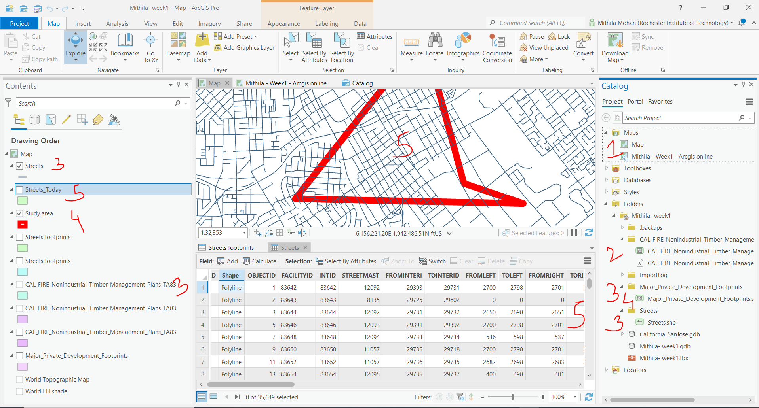

**Step 3: Reflection**

To begin with, my area of interest for this lab was natural disaster such as wildfires. To be more specific I highlighted wildfire risk to communities and buildings. I had few difficulties while finding the imagery layer that I needed. I founded few of them but them didn’t work as I needed them. After few hours of struggle, I could finally find one dataset for the lab. Also, I had difficulties while searching for raster and vector data as well, as they didn’t align with my dataset, I choose for ArcGIS online. It was difficult to me to adjust my raster and vector data and had few problems while I tried to zoom in a particular area. One solution I followed was I went through the videos again and noted and made points of how it was done tried to work on the same dataset and then did the process again on the layers I choose. I tried to focus on how were the surroundings before wildfire affected them and how they are today. There were times where I kept on changing my dataset just to make sure that it works properly. One thing I learned after working on this lab is the visualization. I got an opportunity to analyze, visualize and explore many more datasets. The best things we can learn while working on this lab is explore and try as much as datasets, this gives us an insight of how the dataset will perform when we execute different actions on it. One can use ArcGIS online whenever there is a need to make maps analyze them and share it among the organization. One can directly access maps if they have the URL’s associated with it and this way ArcGIS online can help us to access maps created by anyone across the globe using the URL’s. On the other hand, ArcGIS pro gives us a 3D view of maps. Depending on various needs one can choose to work with either of them.